1. **OBJECTIVES**

Lab 5 aims to implement a system which connects to the internet via an IEEE 802.11 Wifi module, CC3100. We will use DNS to convert web names to IP addresses. We will configure a smart object that can retrieve data from a weather server as well as store data onto another internet server using TCP.

1. **HARDWARE DESIGN**

None.

1. **SOFTWARE DESIGN**

Call Graph:

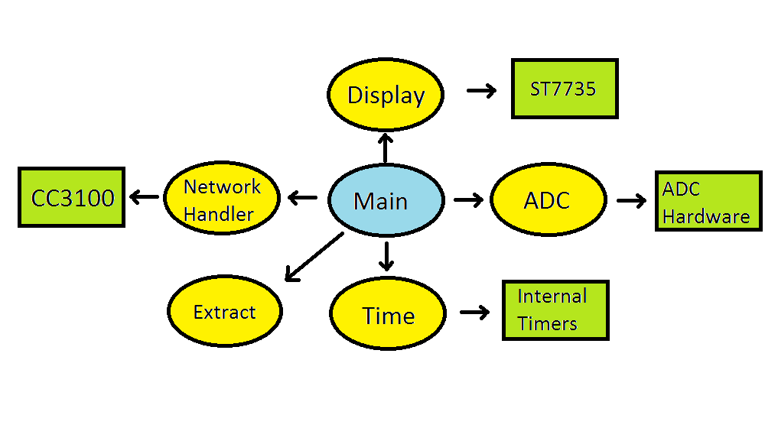

Data Flow Graph:

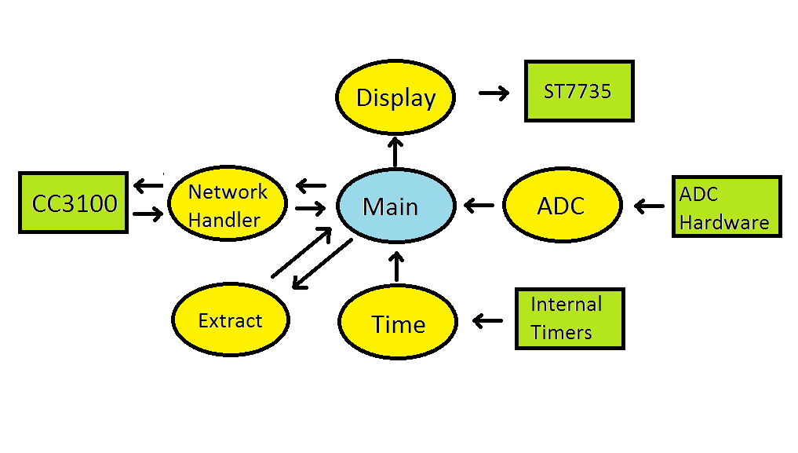

1. **MESUREMENT DATA**

|  |  |  |  |  |  |  |  |  |  |  |
| --- | --- | --- | --- | --- | --- | --- | --- | --- | --- | --- |
| Trial | 1 | 2 | 3 | 4 | 5 | 6 | 7 | 8 | 9 | 10 |
| Time to download (ms) | 29 | 36 | 234 | 266 | 15 | 188 | 294 | 280 | 65 | 32 |
| Time to upload (ms) | 257 | 166 | 166 | 264 | 59 | 161 | 263 | 59 | 59 | 59 |
|  |  |  |  |  |  |  |  |  |  |  |
|  |  |  |  |  |  |  |  |  |  |  |

|  |  |  |  |  |
| --- | --- | --- | --- | --- |
|  | Lost Packets | Avg. Time | Min Time | Max Time |
| Download | 0% | 144 | 15 | 294 |
| Upload | 0% | 151 | 59 | 264 |

1. **ANALYSIS AND DISCUSSION**
   1. **In the client server paradigm, explain the sequence of internet communications sent from client to server and from server to client as the client saves data on the server. Assume the client already is connected to the Wifi AP and the client knows the IP address of the server.**
   2. **What is the purpose of the DNS?**
   3. **What is the difference between UDP and TCP communication? More specifically when should we use UDP and when should we use TCP?**